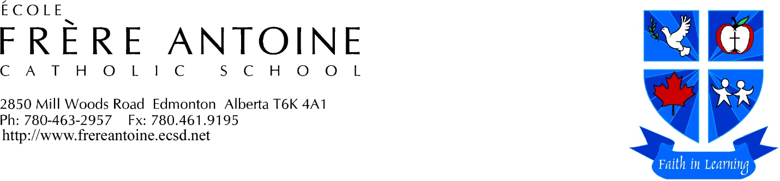
“In one Spirit, we are all baptized into one Body.” (1 Corinthians 12:13)

Student Code of Conduct

Our Student Code of Conduct complies with the newly proposed Alberta Education Act.

We are a caring, safe, welcoming and respectful community. We are committed to living as a people of God in the world. This is achieved through:
- an appropriate balance between individual and collective rights, freedoms and responsibilities in the school community
- clear expectations for student behavior while at school, at a school – related activity or while engaging in an activity that may have an impact on others in the school

In alignment with the Alberta Human Rights Act and the Canadian Charter of Rights and Freedoms, we believe that all persons are equal in: dignity, rights and responsibilities without regard to race, religious beliefs, color, gender (including pregnancy, sexual harassment, and gender identity), physical disability, mental disability, age, ancestry, place of origin, marital status, source of income, family status, or sexual orientation. Discrimination on these grounds is strictly prohibited.

We share an awareness and appreciation of the diverse racial and cultural composition of society and that the richness of life in Alberta is enhanced by sharing that diversity.

We nurture in learners the understanding that we are part of a larger community and that our actions have an impact on others. Behavior greatly affects the quality of our environment. We are responsible for our own behavior that is modeled from the teachings of Jesus Christ. As a disciple of Jesus Christ, our school philosophy and approach to discipline is based on the spirit of Jesus’ teachings. Students and teachers at École Frère Antoine seek a peaceful environment where all can question, learn, experience and grow to their full potential.

Expectations

The Student Code of Conduct sets out behavioral expectations for students, including those behaviors that are consistently promoted, celebrated, modeled and recognized by all in the school community – staff, students, and parents. These expectations are included in the student agenda and on our website. The Student Code of Conduct is reviewed with students periodically throughout the school year.

Creating this environment requires the co-operation, full attention and best efforts of students, staff and parents working together. We are a single-track French Immersion school and as such the expectation is that communication be in French during class, noon and recess times to get the most out of the Immersion experience.

Acceptable Behaviors
At École Frère Antoine students will:

Be Respectful
- be honest and truthful
- find out about other people’s feelings
- accept others’ differences
- care for other people’s belongings and public property
- listen attentively when required
- use polite language and behavior
- wear appropriate clothing and footwear as per school policy
- cooperate with school staff

Be Leaders
- be welcoming of others
- practice positive comments
- be cheerful
- be team players
- look for ways to improve our school
- be a positive ambassador for our school
- resolve conflicts in a peaceful manner

Be Safe
- move quietly in hallways
- play safely in the playground (bullying, play-fighting, snowballs are not allowed)
- use equipment properly
- stay on school property
- stay away from parking lot
- report any injuries, problems, conflicts or dangerous behavior to adult supervisors right away
- listen to class monitors during lunch
- stay in designated areas

On the Bus
- respect the bus drivers
- remain seated
- wait for bus to stop before moving
- talk quietly
- obey the rules as set by ECSD Transportation Division
- https://www.ecsd.net/SchoolProfiles/transportation/Pages/School-Bus-Safety-Video.aspx

Be Ready to Learn
- attend school regularly and punctually
- do homework and bring it back to school on time
- have school materials ready
- use agenda daily
- be ready to learn and actively engage in your education

Conflict Resolution and Reconciliation

When individuals are involved in conflict, they are encouraged to discuss it together as soon as possible to find a solution. When needed, they will seek the help of a mediator. The mediator explores with individuals how to adapt or respond to a situation, with consideration to age, maturity and individual circumstances.

The dignity of each person will be respected by:
- identifying the inappropriate behavior
- describing its effects upon the situation
- giving the individual the opportunity to provide input into the reconciliation process

This process requires practice for individuals to become proficient in asserting their needs as well as apologizing and forgiving one another. All cases are treated individually. Confidentiality is stressed to protect privacy.

Bullying

The Education Act defines bullying as repeated and hostile or demeaning behavior by an individual in the school community where the behavior is intended to cause harm, fear or distress to one or more other individuals in the school community, including psychological harm or harm to an individual’s reputation.

At École Frère Antoine students will:

- refrain from, report and refuse to tolerate bullying or bullying behavior, even if it happens outside of the school or school hours or electronically;
- inform an adult you trust in a timely manner of incidents of bullying, harassment, intimidation or other safety concerns in the school

Students may report bullying by:
- telling an adult at the school
- telling a parent or guardian
- calling the Kids’ Help Line: (1-800-668-6868)

Unacceptable behavior

Students will be held accountable for conduct that occurs within and outside of the school day, including the inappropriate use of social media and electronics.

Examples of unacceptable behaviors may include:
- behaviors that interfere with the learning of others
- behaviors that interfere with the school environment or that create unsafe conditions
- acts of bullying, harassment or intimidation
- physical violence
- retribution against any person in the
school who has intervened to prevent or report bullying or any other incident or safety concern
- illegal activities such as:
- possession, use or distribution of illegal or restricted substances
- possession or use of weapons
- theft or damage to property

Consequences for unacceptable behavior take into account age, maturity and individual circumstances. Any special needs that the student has – whether they are physical, behavioral, communicational, mental health, trauma, etc. – are considered.

Consequences may include:
- mentoring
- restorative processes
- regular check-ins with teachers or EBS
- counselling
- parent conferences
- student reflection
- behavioral contracts
- review of privileges
- bus suspensions
- in and out of school suspensions
- recommendations for expulsion

A severe breach of conduct will result in a suspension in accordance with Section 31 of the Education Act.

A continuum of supports may be provided to students who are impacted by inappropriate behavior as well as for students who engage in inappropriate behavior.

These may include:
- wrap-around services including Multidisciplinary Team (behavioral therapists, etc.), Inclusive Support Team (Family School Liaison Worker, etc.), Regional Collaborative Service Delivery (Mental Health Therapists, etc.).

